Page no.29

**Probability Distribution :**

Probability of all possible scenarios.

Ex. When dice is thrown p(1) = 1/6 , p(2) = 1/6 …. P(6) = 1/6

These are probabilities of getting 1,2,…,6 but

Is thought Collectively of all 6 probabilities (set of 6 probabilities) it is called **probability distribution**

Random Experiment : we don’t know exact outcome but know all possible outcomes

Random Variable: when we store the possible outcomes of any random experiment it is called random variable

**Discrete random variable** : countable random variable

Ex. Random variable of dice

**Continuous random variable** : uncountable random variable

Ex. Random variable of probabilities of getting missed calls

Probability Mass Function : in a variable , sum of all probabilities must be 1 and all probabilities must be positive. Then we can say it is a probability mass function.

**Discrete probability distribution** : all probabilities are same in a variable.

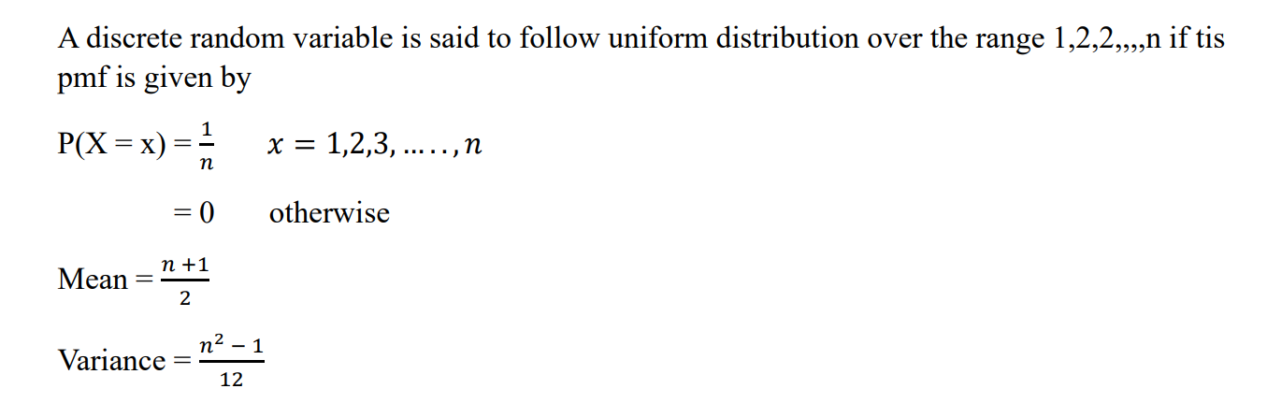

To find probability of 1 success : binomial distribution

To find probability of 1st success :